**BIG DATA**

* Huge and complex data sets that normal Software can’t handle.
* Ex: data from Social media, videos, transactions, etc

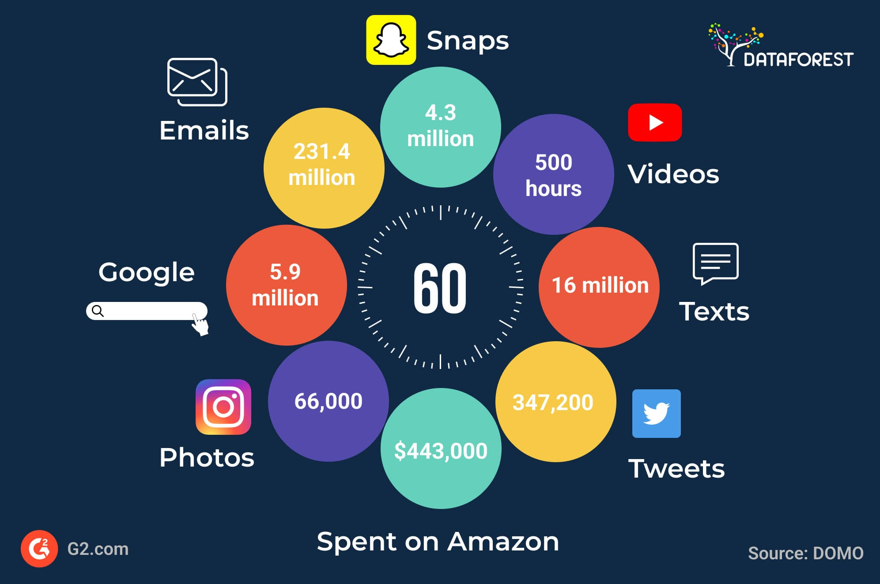

**MAIN FEATURES:**

* Volume
* Velocity
* Variety
* Veracity

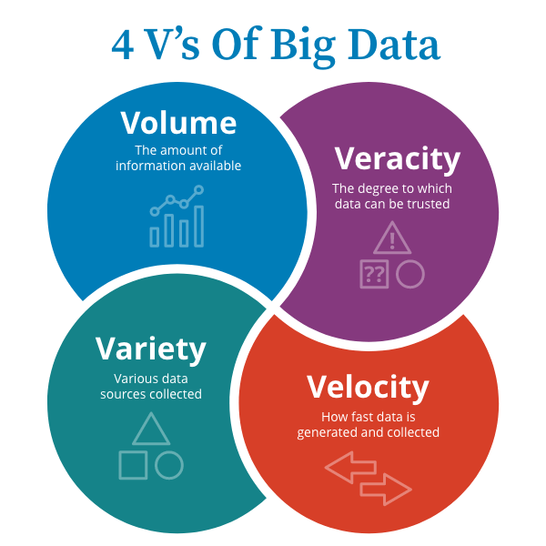

**VOLUME:**

* Indicates the amount of data we have.
* Ex: Social media generates terabytes of data daily.
* Need systems that can store and handle this huge amount.

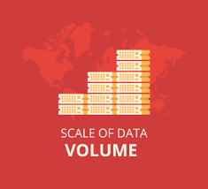

**VELOCITY:**

* How fast data is coming in.
* Ex: Twitter processes millions of tweets per day.

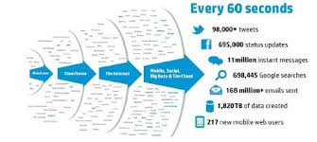

**VARIETY:**

* Different types of data processed.
* Structured: Databases.
* Semi-structured: XML, JSON.
* Unstructured: Images, videos, emails
* Ex: Amazon handles orders (structured), customer reviews (semi-structured), and product photos (unstructured).

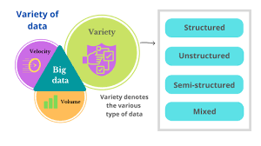

**VERACITY:**

* Refers to data accuracy.
* Data can be messy, incomplete or wrong leading to data loss.
* Ex: insufficient data for processing in Health care Industry.

